SITE SENSITIVITY VERIFICATION REPORT FOR THE WILDEBOSCH ROAD EXTENSION TO TRUMALI ROAD, SITUATED ON VARIOUS PROPERTIES IN STELLENBOSCH SOUTH, WITHIN THE JURISDICTION OF STELLENBOSCH LOCAL MUNICIPALITY IN THE WESTERN CAPE

Background
Stellenbosch Local Municipality under the Department of Roads and Stormwater proposes to develop a road alignment between the suburbs of Paradyskloof and Brandwacht. The project would include an extension of the Wildebosch Road and upgrading Trumali Street at Stellenbosch.
As can be seen in Figure 1 the proposed Wildebosch road extension commences at Paradyskloof Road and traverses’ erven Erf 16527 - RE Farm 369 in a north-westerly direction to meet Trumali Street. The existing Trumali Street will be upgraded as part of the project.
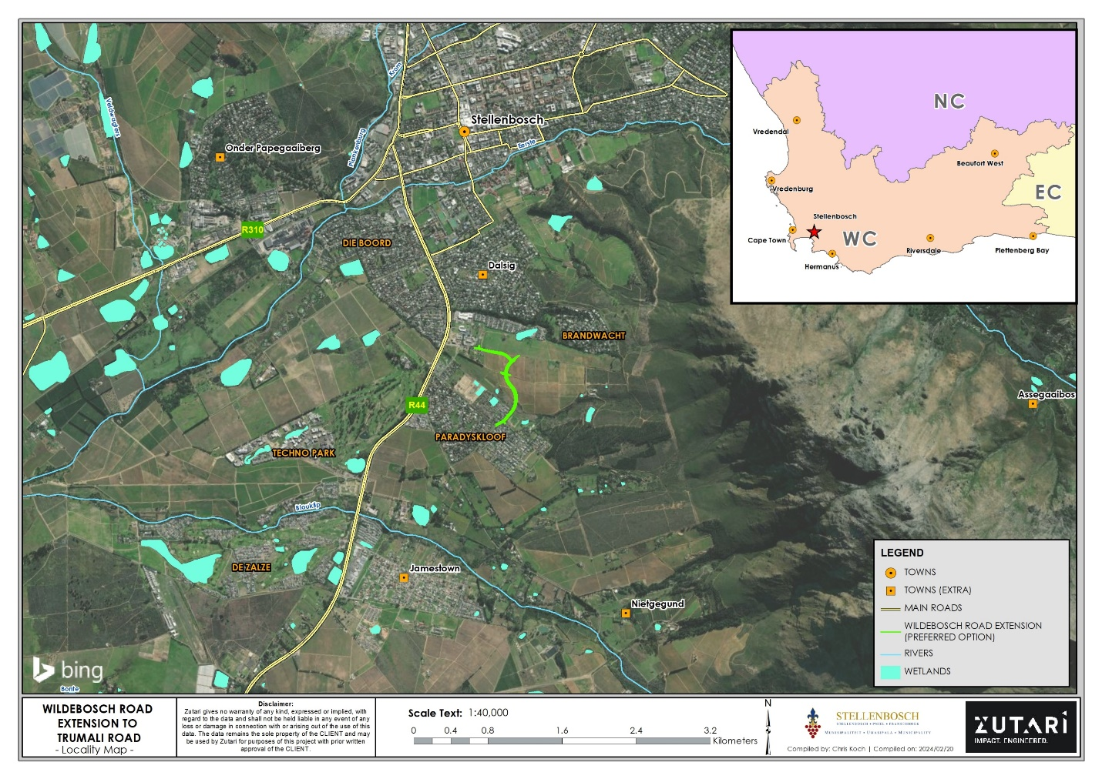
Figure 1: Proposed site Locality
The project footprint would be situated on the following properties:
- Erf 16527 Stellenbosch Township Stellenbosch RD (Hereafter referred as “Erf 16527”)
- RE Farm 369 Stellenbosch RD (Hereafter referred as “RE Farm 369”)

Purpose of the Report
Stellenbosch Municipality appointed Zutari to undertake the required Basic Assessment (BA) Environmental Process in terms of the National Environmental Management Act, 1998 (No. 107 of 1998) (NEMA) and the 2014 Environmental Impact Assessment (EIA) Regulations in order to seek authorisation for the proposed road works.
A screening tool report was generated, and the sensitivities identified for the site are included in Table 1.
Table 1: Environmental sensitivities as per the national screening tool.
Theme | Very High sensitivity | High sensitivity | Medium sensitivity | Low sensitivity
Agriculture Theme | X
Animal Species Theme |  | X
Aquatic Biodiversity Theme | X
Archaeological and Cultural Heritage Theme | X
Civil Aviation Theme |  | X
Defence Theme |  |  |  | X
Palaeontology Theme |  |  |  | X
Plant Species Theme |  |  |  | X
Terrestrial Biodiversity Theme | X

Whilst the above sensitivities were identified for the site, a number of specialist studies have been identified for inclusion in the environmental process and are listed below. The bolded text indicates themes for which a sensitivity was identified by the National Screening Tool. It is the responsibility of the Environmental Assessment Practitioner (EAP) to confirm this list and to motivate in the assessment report, the reason for not including any of the identified specialist study
- Agricultural Impact Assessment
- Landscape/Visual Impact Assessment
- Archaeological and Cultural Heritage Impact Assessment
- Palaeontology Impact Assessment
- Terrestrial Biodiversity Impact Assessment
- Aquatic Biodiversity Impact Assessment
- Civil Aviation Assessment
- Noise Impact Assessment
- Traffic Impact Assessment
- Geotechnical Assessment
- Socio-Economic Assessment
- Ambient Air Quality Impact Assessment
- Plant Species Assessment
- Animal Species Assessment
In accordance with the Procedures for the Assessment and Minimum Criteria for Reporting on identified Environmental Themes in terms of Sections 24(5)(a) and (h) and 44 of NEMA, Zutari compiled this Site Sensitivity Report to provide a rationale for the specialist studies to form part of the requisite environmental authorisation process that is undertaken for the project.

Desktop Analysis
To determine the level of environmental sensitivity pertaining to the proposed road extension, Zutari has used the following desktop information/tools (i.e., Geographic Information System data) for analysis:

- South African National Biodiversity Institute (SANBI): National Wetlands Map 4 (National Freshwater Ecosystems Priority Areas Wetlands Map) [NFEPA];
- Bing Arieal Image; and
- Cape Farmer Mapper 3.
In terms of the Cape Farmer Mapper 3 agricultural dataset, a large portion of the project footprint is situated within an agricultural area. Particularity, the area between Paradyskloof and Trumali Road is used for berries and grapes farming (as per the Crop Census, 2017 Summer Summary). As recommend in the national screening tool an agricultural compliance statement will be conducted as part of the BA process.
Based on the Cape Farm Mapper 3 dataset, the project falls under the Berg Water Management Area, within Quaternary Catchment G22H. It appears the road extension would be crossing a drainage line/non-perennial river at three different points (according to Rivers NGI dataset). Since there are NFEPA wetlands situated within the 500m radius of the site, the proposed road extension would likely occur within the 500m regulated area of a wetland, and this is subject to confirmation. A Freshwater Aquatic Ecological Assessment is being conducted to confirm wetlands or watercourses on site and verify if further authorisations are required. It is likely that a Water Use Licence in terms of the National Water Act (Act No. 36 of 1998) would be required to authorise the intended road extension. This must be confirmed in consultation with the Department of Water and Sanitation (DWS).
According to the Cape Farm Mapper 3, the site is located within the Cape Winelands Biosphere Reserve and comprising of Swartland Shale Renosterveld vegetation type. It appears that the project site is not located within a Critical Biodiversity Area (CBA), Ecological Support Area, or Other Natural Area. However, a small section within the proposed Trumali Road upgrades appears to be situated within a CBA. Although this small area has already been degraded and transformed by the original (Trumali) road construction a Botanical Assessment has been conducted as part of the BA process.

Site Visit / Assessment
A botanical specialist has investigated the site and concluded that the proposed works would not result in unacceptable levels of flora impacts as long as all mitigation measures are applied. A large section of the site has undergone significant transformation and disturbance, preserving little to no original vegetation.
Based on the Freshwater Aquatic Assessment undertaken on December 2023 by FEN Consulting, an unchanneled valley bottom wetland (UCVBW) was identified on site and delineated. The proposed road extension will traverse this delineated UCVBW. Mitigation measures recommended by the freshwater aquatic specialist must be adhered to. All mitigation measures will be included in the EMPr.
According to the Agricultural Site Sensitivity Verification, the site falls outside of an area classified as a Protected Agricultural Area (PAA). A large portion of the road extension between Paradykloof (where the extension commences) and Trumali Road is high potential vineyard land. However, the road construction will be localised and limited to the road footprint only. Thus, resulting into a localised impact. The agricultural specialist indicated that a detailed soil map and the identification of whether soils are Pinedene or Tukulu or Kroonstad is of little relevance to the agricultural assessment. What matters is that the impacted land is high potential vineyard.

Motivation / Rationale for Specialist Studies
- Agricultural Impact Assessment
  - The screening tool report identified a very high sensitivity for this theme. An agricultural compliance statement will be compiled by an agricultural specialist. As indicated above, a portion of the road extension falls within an existing agricultural land use.

- Landscape and Visual Impact Assessment
The landscape and visual impact assessment has been conducted and findings of this study concluded that the overall combined anticipated landscape and visual impacts of the site is expected to be minimal and from a visual perspective it is not fatally flawed.

- Archaeological and Cultural Heritage Impact Assessment
  - High sensitivity of this theme was identified by the screening tool, and a desktop heritage impact assessment was conducted.

- Palaeontology Impact Assessment

The low sensitivity was identified by the screening tool, and therefore a palaeontological impact assessment is not necessary.

- Terrestrial Biodiversity Impact Assessment
A botanical assessment has been undertaken as part of the terrestrial biodiversity by a botanical specialist. The road extension will take place within an urban area that is already impacted and transformed largely by agricultural activities and residential land uses. There is no pristine natural habitat capable of accommodating floral and faunal species of concern within the project footprint.
- Aquatic Biodiversity Impact Assessment
  - An aquatic impact assessment as per the protocol has been undertaken by an aquatic specialist.

- Noise Impact Assessment
The project intends to extend and upgrade existing roads and the speed limits must remain the same. Noise impact assessment is deemed to be unnecessary. Noise is expected to increase during the construction phase as a result of construction machinery, vehicles and workers. However, this noise increase will be limited to the construction phase only.

- Traffic Impact Assessment
  - The primary objective of the project is to provide alternative road alignment and the works are specifically proposed to improve traffic within Stellenbosch South. Traffic impact assessment deemed to be necessary.

- Geotechnical Assessment
  - A geotechnical investigation will be undertaken as part of the engineering scope and therefore deemed not necessary for the environmental study.

- Socio-Economic Assessment
  - The project aims to extend and upgrade existing roads and would improve the traffic flow and safety of the road users, therefore, having a positive impact on the socio-economic landscape. This project will not have significant negative impacts on the socio-economic conditions of the area. Therefore, a socio-economic impact assessment is deemed necessary.

- Ambient Air Quality Impact Assessment
  - The project aims to extend and upgrade existing roads and an air quality impact assessment is deemed not to be required. This type of development will not result in any greenhouse emissions (i.e., emissions through a stack or vent) during construction and operation. It is anticipated that dust would emanate from the construction activities, such as the movement of excavators, dump trucks, trackor loader backhoe and other heavy vehicles. Dust control measures are included in the Environmental Management Programme (EMPr).

- Plant Species Assessment
A botanist has been appointed to undertake a botanical assessment.

- Animal Species Assessment
An animal species impact assessment is not deemed necessary as the road works will be undertaken within an urban area, agricultural land and residential area that is already transformed, impacted, and disturbed. The high sensitivity of the screening tool report is disputed as this should rather be low for the transformed study area. A specialist has been appointed to undertake the required fauna compliance statement.

- Civil Aviation Theme
A suitably qualified specialist has been appointed to conduct the civil aviation compliance assessment.

- Defence Theme
No studies or statements are required for the defence theme.

Conclusion
This site sensitivity verification reports were compiled in line with the protocols for impact assessments and guided by the screening tool report generated for the project. As detailed above the site for the proposed project is inside an existing urban area comprising of a built environment, agricultural and residential land uses. Therefore, to a larger degree the study area has already been impacted and transformed by the existing land uses, showing none to little pristine natural environment. It is recommended that mitigation measures provided by the specialists and that are contained in the EMPr must be adhered to. As the road extension may cross an aquatic ecosystem, it is important that a Freshwater Aquatic Assessment be undertaken for the project.
The screening tool recommended a number of specialist assessments and revealed different sensitivities for the site. This report provides a rationale for which specialist studies/inputs will be acquired for the project.

Declaration by the EAP with signature confirming that the information submitted is correct:
Document Control
Project name |  | Wildebosch Road Extension to Trumali Road
Document Title |  | Site Sensitivity Verification Report
Document number |  | 1 | Project number |  |  | 1002111
Client |  | Stellenbosch Local Municipality
Client contact |  | Johan Fullard (Senior Manager)  Lehlohonolo Moreki (Project Leader) | Client reference
Rev | Date | Revision details/status | Author | Reviewer |  | Verifier  (if required) | Approver
A | 2023/01/14 | Internal Draft Report | Siphamandla Mzolo | Xanté Eberhardt |  |  | Xanté Eberhardt
B | 2024/01/31 | Draft for Client Review | Siphamandla Mzolo | Johan Fullard  Lehlohonolo Moreki |  |  | Xanté Eberhardt
Current revision |  | 0

Approval
Author signature |  | Approver signature
Name | Siphamandla Mzolo | Name | Xanté Eberhardt
Title | Environmental Consultant | Title | Environmental Assessment Practitioner

